R-J Sammé – 11Y2

This content is not intended to be modified or redistributed in any way. © R-J Sammé 2021

Physics – P5

Electricity in the home

Headings:

Alternating Current

Mains Circuits

The National Grid

Cables and Plugs

Short Circuits

Power

Fuses

Efficiency

Equations:

Power = Energy ÷ Time

Power = Current x Potential Difference

Efficiency = Useful Power x Total Power

Diagrams:

Alternating Current

Plugs

The National Grid

Alternating Current

The battery in a torch makes the current flow in one direction, from the negative to the positive, this is called direct current (DC). However, mains electricity (for example in your house) uses alternating current (AC). Alternating Current changes the direction of flow over time, between positive and negative.

The rate at which the directions changes is called the frequency. In the UK, the frequency is 50Hz.

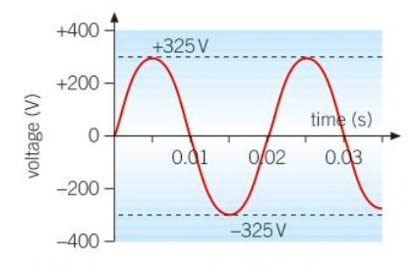

Mains Circuits:

In every mains circuit there is a live wire, and a neutral wire. The neutral wire is earthed at the substation. The Potential Difference between the earth and the live wire is the voltage. The live wire can be dangerous because the voltage in a live wire reaches +325v and -325v.

The National Grid:

The mains appliances in your house are powered from the National Grid – a nation-wide network of cables and transformers. An average power station generates AC electricity at 25,000 V.

* Step-up Power Transformers are used at power stations to connect the station to the national grid. They raise the voltage from a power station’s 25,000 V to 132,000 V.
* Step-down Power Transformers are used to supply energy to consumers. They reduce the voltage from 132,000 V to 230v in houses, and either 100,000 V or 33,000 V for factories.

The reason that the voltage of the grid is so high is because it allows for a very low current, meaning less energy is lost through the wires heating up. This is why the national grid is very efficient.

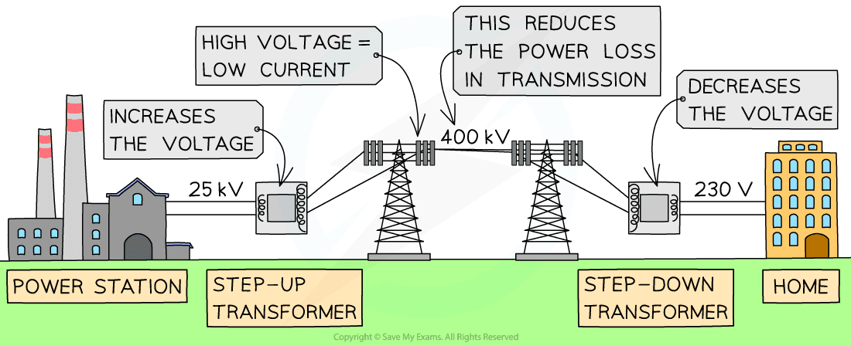

Cables and Plugs:

Any device with a metal case is connected to earth using an earth pin. This ensures that, in the event of a fault or short circuit, the metal case will not become live, potentially giving you a shock. Devices with plastic cases do not require an earth connection, as they are double insulated.

The main casing of appliances are made of electrical insulators to prevent electric shocks. Most appliances are connected to the mains using a three-pin plug.

The three pins in a plug are connected to three wires:

* The earth pin is connected to the ground in your house (yellow and green wire) and protects you from faults.
* The live pin is connected to the brown wire and carries the electrical current. There is a fuse between the pin and wire to prevent too much current.
* The neutral pin is connected to the neutral wire.

Short Circuits

If a live wire touches a neutral wire, a huge current passes between the wires. This is known as a short circuit. Normally, the fuse will blow, shutting of the circuit. However, even if an appliance is shut off, you should never touch the live wire, as you could receive a lethal shock.

Power:

When a device is used, the current through it transfers energy. The power of an appliance (W) is the amount of energy it transfers in joules/second (j/s).

Power can also be calculated if you know the Potential Difference and Current:



Fuse Ratings:

Most appliances have either a 3A, 5A or 13A fuse. A fuse contains a thin piece of wire which melts if the current passing through it is too high. If the wire melts, the circuit is broken, and the device will not work.

Efficiency

When a device is used, some energy will be lost through wire heating or friction. The amount of energy that is wasted is called efficiency. The efficiency of any device (%) can be calculated using the input power and output power:

